Fitted Model of X2

The t-value is too low to reject the null hypothesis at the 95% level. Inferentially, it should be noted that this parameter does not enter the equation linearly. The p-value is strong, signifying that this is not by chance.

| **Parameter Estimates** | | | | | |
| --- | --- | --- | --- | --- | --- |
| **Variable** | **DF** | **Parameter Estimate** | **Standard Error** | **t Value** | **Pr > |t|** |
| **Intercept** | 1 | 13.95000 | 4.46398 | 3.13 | 0.0049 |
| **X2** | 1 | 17.72500 | 3.75049 | 4.73 | 0.0001 |

Diagnostics for X2

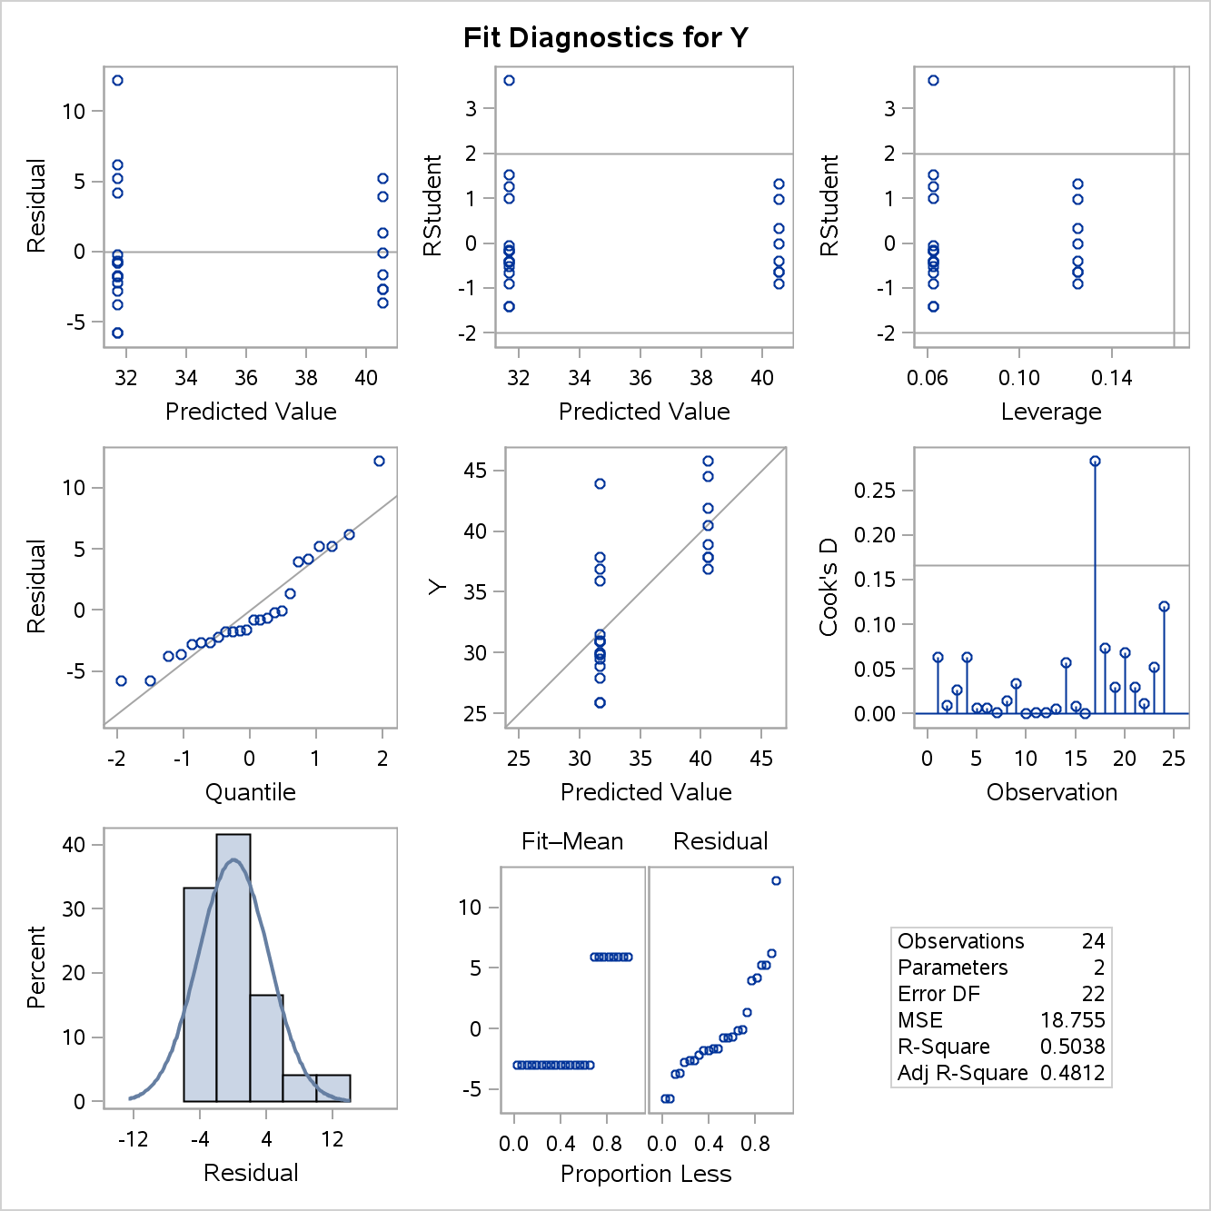

The OLS assumption being violated is the linearity assumption. It can clearly be seen that the data does not enter the plot linearly. Is this accurate?

